**Power BI Assignment 2**

1. **Explain the advantages of Natural Queries in Power BI with an example?**

The Q&A feature in Power BI lets you explore your data in your own words by using natural language.

Below are some of the advantages of Natural Queries have:

1. Sometimes it is the fastest way to get an answer from your data.
2. Q&A is interactive and improve customer satisfaction.
3. Power BI Q&A is free and available to all users.
4. Streamline processes and reduce costs
5. Get a more objective and accurate analysis

 Q&A supports a wide range of questions. You can:

* **Ask natural questions** Which sales has the highest revenue?
* **Use relative date filtering** Show me sales in the last year
* **Return only the top N** Top 10 products by sales
* **Provide a filter** Show me sales in the USA
* **Provide complex conditions** Show me sales where product category is Category 1 or Category 2
* **Return a specific visual** Show me sales by product as pie chart
* **Use complex aggregations** Show me median sales by product
* **Sort results** Show me top 10 countries/regions by sales ordered by country/region code
* **Compare data** Show me date by total sales vs total cost
* **View trends** Show me sales over time

1. **Explain Web Front End(WFE) cluster from Power BI Service Architecture?**

Power BI Service’s architecture consists of two parts:

* A front end
* A back end

The front end also called the web front-end cluster acts as an intermediary between clients and the back end. The front end services are used for establishing an initial connection and authenticating clients using Azure Active Directory. The Azure Active Directory stores user identities.

Along with this, Azure Traffic Manager is used to direct user requests to the nearest data center after authentication. Once a client/user is authenticated, the **Azure Content Delivery Network (CDN)** distributes static Power BI content/files to users.

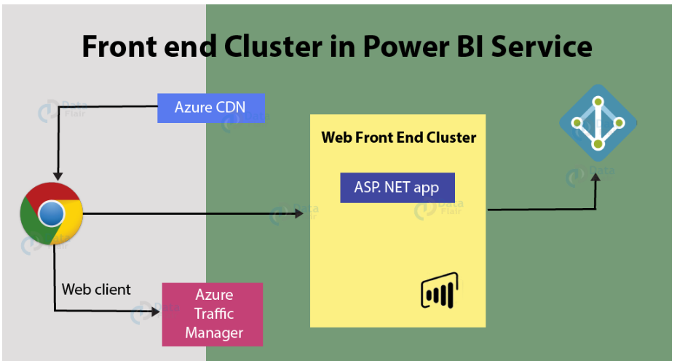

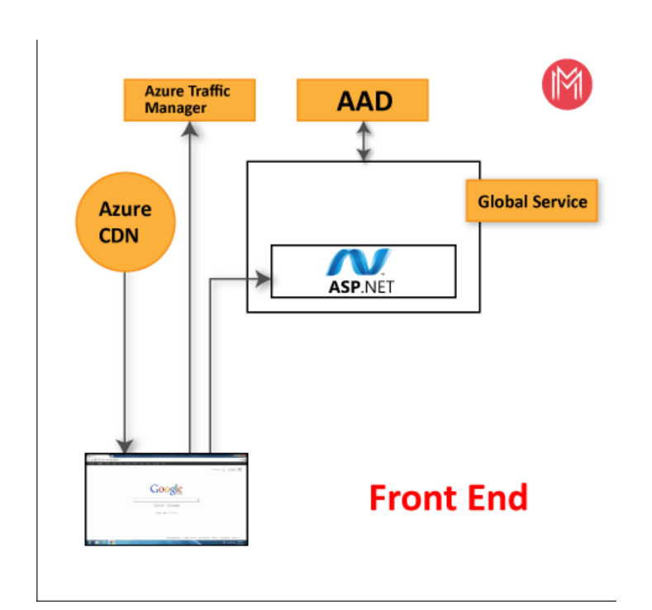

1. **Explain Back End cluster from Power BI Service Architecture?**

The Back End Cluster of Power BI Services Architecture take care of*visualizations, datasets, storage, reports, data connections, data refreshing, and other interactions* with Power BI. At the back-end, a web client has only two direct points of interaction, **Azure API Management**, and **Gateway Role**. These two components are responsible for *load balancing, authentication, authorization, routing,* etc.

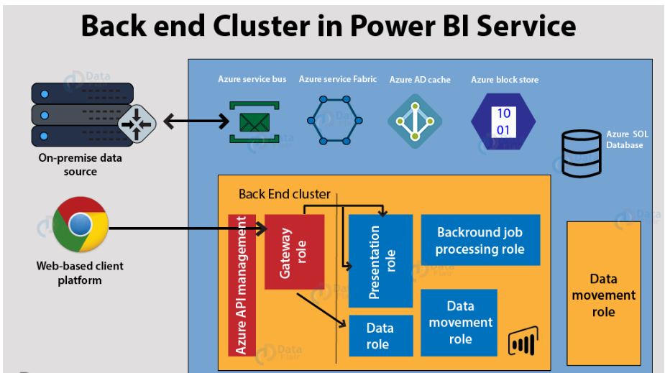

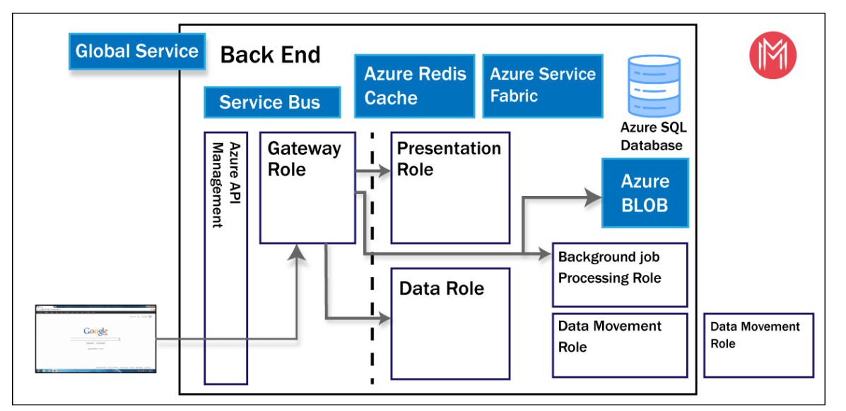

* After Azure API Management authenticates a user request, it is sent to the Gateway Role. The Gateway Role processes the requests and directs them to suitable components like *Presentation Role, Background Job Processing Role, Data Role, and Data Movement Role.*
* For instance, the Presentation Role handles all the visualization related queries like for dashboards and reports.
* For all the data related queries, the request is sent by the Gateway Role to the Data Role or Data Movement Role.

1. **What ASP.NET component does in Power BI Service Architecture?**

With the help of ASP.NET component, Power BI reports can be embedded in a web page or web application.

1. **Compare Microsoft Excel and PowerBi Desktop on the following features:**

|  |  |  |
| --- | --- | --- |
|  | **EXCEL** | **POWER BI** |
| **Data import** | Limited connectivity with other applications and systems. | You can extract data from virtually any platform, software and application. |
| **Data transformation** | Fewer data analysis options than Power BI. It used MDX language. | It uses DAX language, which gives it more powerful analytical capabilities than excel. |
| **Modeling** | Ability to work on simple and structured data models. | Ideal for building complex data models easily. |
| **Reporting** | Simple and less attractive reports than those of Power BI. | More beautiful, personized, attractive and interactive reports. |
| **Server Deployment** | It can’t be deployed on server. | It can be deployed on server. |
| **Convert Models** |  |  |
| **Cost** | Payment tool. | It has a free version and a payment version. |

1. **List 20 data sources supported by Power Bi desktop.**

The Get Data dialog box organizes data types in the following categories:

* All
* File
* Database
* Power Platform
* Azure
* Online Services
* Fabric
* Other

**File data sources**

The **File** category provides the following data connections:

* Excel Workbook
* Text/CSV
* XML
* JSON
* Folder
* PDF
* Parquet
* SharePoint folder

**Database data sources**

The **Database** category provides the following data connections:

* SQL Server database
* Access database
* Oracle database
* IBM Db2 database
* MySQL database
* PostgreSQL database
* Teradata database
* SAP HANA database
* SAP Business Warehouse Application Server
* SAP Business Warehouse Message Server
* Amazon Redshift
* Snowflake
* BI Connector
* MongoDB Atlas SQL (Beta)